**Final Project**

**Context of the problem:**

The globalization in these days force us to talk and understand the language of a lot of different people of many difference country.

For our country that have like main language the Spanish, one of the most needed languages is the English because is one of the most important ones, in many circles like business, medicine, etc. “Speaking and writing English its essential in the business world” [1] according to “Adecco” (an international company specialized in job search) the “72.55% of the job offers require knowledge of a foreign language” [1].

The problem is that not all the people have the skills to talk in another language besides their main language. So that’s why there are a lot of online translators but as we said they are online and in most of the cases when you are in another country trying to speak in another language you don’t have access to online resources.

**Solution:**

The solution consists in a translator from Spanish to English that will help people because it Is really easy to use and can be use without the need of an internet connection.

The translator has some pre-define grammatical rules, but it is really easy to add more rules in order to make the translator more complete.

To be available for all the people the translator is open source and can be download from my account of GitHub.

**Results**

The result is a translator created in prolog that translate words and sentences in past and present in all the conjugations from Spanish to English

It is made in prolog because it is really easy to implement in this language, actually one of the first uses of the language was this kind of projects.

It is easy because it is like making a compiler where you just need to define your grammar rules(DCG). Until you get to your “terminals” and then your “tokens” that are the words that are in Spanish and their translation in English.

For example, this rule work for translate independent words (nom)

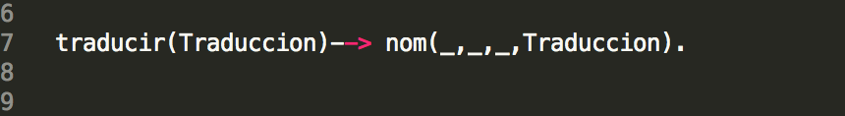

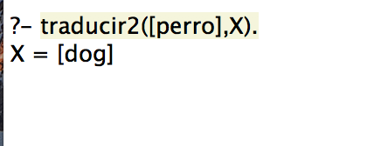

This one translate sentences that have independent words (nom) and verb

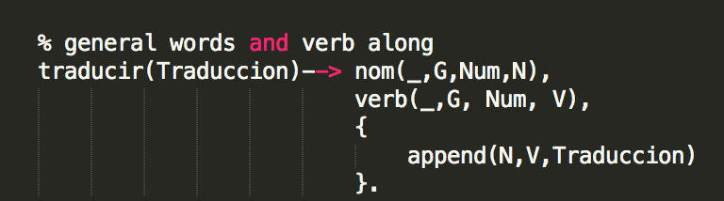

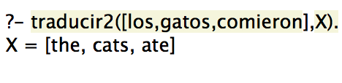

This are just two examples of the grammar rules that are defined, at this moment, the translator has 14 different grammar rules that combined can translate words alone or sentences with different grammar order.

To define a “token” is really simple too, the tokens can be: “articuloT” (articles), “adjetivoT”(adjectives), “nombreT” (all kind of words), “verbT” (verbs), and “preposicionT”(prepositions).

This is an example of an “adjetivoT” definition:

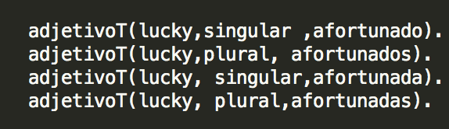

adjetivoT (English word, singular or plural, Spanish word)

This is an example of an “NombreT” definition:

/Users/Imacggarcia/Desktop/Captura de pantalla 2018-04-23 a la(s) 21.48.54.png

nombreT (Spanish word, masculino or feminino, English word).

At this moment, this are the defined tokens that are in the translator:

|  |  |  |
| --- | --- | --- |
| **Kind** | **Number** | **token** |
| Verbs | 10 | comer, dormir, beber, jugar estudiar correr escribir, nadar, hablar, pensar. |
| Adjectives | 9 | afortunado, sencillo complete, enorme, divertido, complicado, estupendo, rojo, anaranjado. |
| Articles | 8 | el, la, los, las, un, una, unos, unas |
| Words | 26 | yo, tu, el, ella, nosotros, ustedes, ellos, patinador, patinadora, corredor, corredora, joven.  platano, manzana, perro-caliente, hamburguesa.  perro, gato, pez.  examen, computadora, libro, lápiz, juego.  dia, semana |
| Prepositions | 5 | en, durante, contra, entre, desde, por. |

**Tests:**

For the way in which the grammar was defined this are some of the test that have to pass:

**Test 1: article alone**

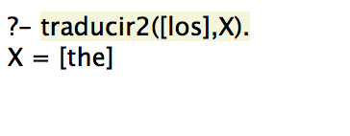

**Test 2: article + word**

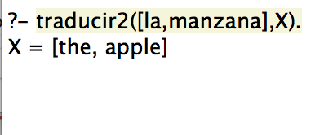

**Test 3: article + word + verb (present)**

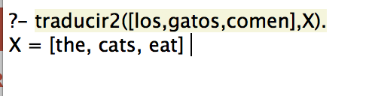

**Test 4: article + word + verb (past)**

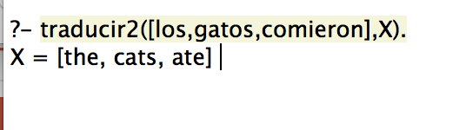

**Test 5: article + word + verb (present) + article**

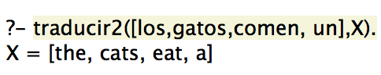

**Test 6: article + word + verb (past) + article**

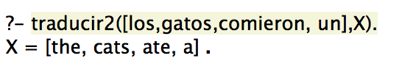

**Test 7: article + word + verb (present) + article + word**

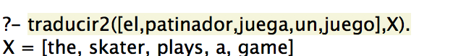

**Test 8: article + word + verb (past) + article + word**

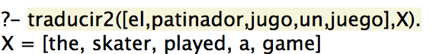

**Test 9: article + word + verb (present) + article + word + adjective**



**Test 10: article + word + verb (past) + article + word + adjective**

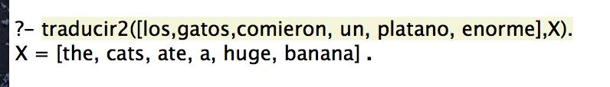

**Test 11: word + verb (present) + article + word**

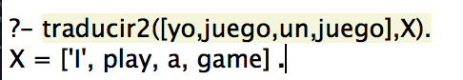

**Test 12: word + verb (past) + article + word**

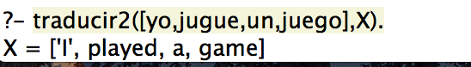

**Test 13: word + verb (present) + article + word, adjective**

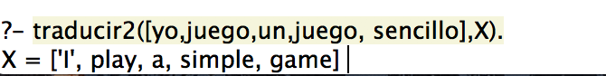

**Test 14: word + verb (past) + article + word, adjective**

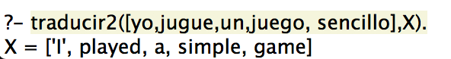

**Test 15: word alone**

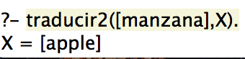

For the way in which the grammar was defined this are some of the test that did NOT have to pass:

**Test 16: word alone that is not defined**

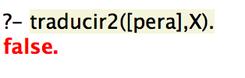

**Test 17: misspelling word**

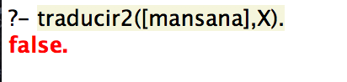

**Test 18: grammar mistake in the article**

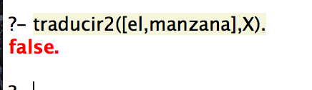

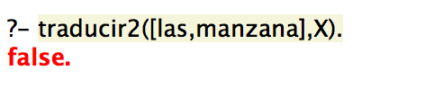

**Correct:**

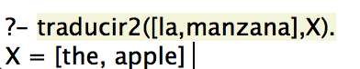

**Test 19: grammar mistake in the conjugation of the verb**

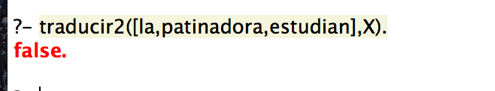

**Correct:**

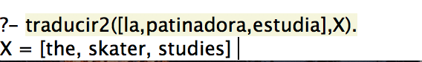

**Test 20: not defined rule (article + word + verb (past) + article + adjective + word)**

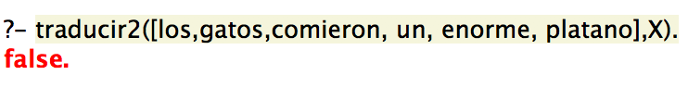

**Setup Instructions**

1. Download and install Prolog from the web page:

<http://www.swi-prolog.org/download/stable>

1. Download the project from GitHub:
2. Open SWI-Prolog
3. Load the project example:/Users/Imacggarcia/Downloads/Captura de pantalla 2018-04-23 a la(s) 23.10.31.png
4. Make a translation using the function “traducir2”.
5. For the translations you need to open “[“ the write your sentence dividing every word by a comma an then close “]” then another comma and a variable. Example



**Conclusions**

I hope that this translator will help people to translate words from Spanish to English it have one major advantage and this is that it did not need internet connection.

And this moment the number of word or sentences that can translate it’s not that big but other advantage is that it’s really simple to add more words actually you don’t need to be a programmer to know how to define more words.

Defining a rule, it’s a little more complicated but you don’t need to be an expert in the language to understand the code and do this.

For these reasons, I think that this translator can be useful for many people

**References**

**[1]** -. (2017). Los idiomas más importantes en el mundo de los negocios. abril 23 2018, de language institute Sitio web: https://espanolenespana.es/sin-categorizar/los-idiomas-mas-importantes-en-el-mundo-de-los-negocios/

Patrick Blackburn, Johan Bos, and Kristina Striegnitz. (2006-2012). chapter 8 definite clause grammars . abril 23 2018, de learn prolog now! Sitio web: http://www.learnprolognow.org